PRACTICAL NO.9
a. Database Programming with SQLite
Code:
activity_main.xml
<?xml version="1.0" encoding="utf-8"?>
<androidx.constraintlayout.widget.ConstraintLayout xmlns:android="http://schemas.android.com/apk/res/android"
xmlns:app="http://schemas.android.com/apk/res-auto"
xmlns:tools="http://schemas.android.com/tools"
android:layout_width="match_parent"
android:layout_height="match_parent"
tools:context=".MainActivity">
<EditText
android:id="@+id/un"
android:layout_width="0dp"
android:layout_height="wrap_content"
android:layout_marginStart="32dp"
android:layout_marginEnd="32dp"
android:ems="10"
android:hint="Enter Username"
android:inputType="textPersonName"
app:layout_constraintBottom_toBottomOf="parent"
app:layout_constraintEnd_toEndOf="parent"
app:layout_constraintHorizontal_bias="0.497"
app:layout_constraintStart_toStartOf="parent"
app:layout_constraintTop_toTopOf="parent"
app:layout_constraintVertical_bias="0.062" />
<EditText
android:id="@+id/pass"
android:layout_width="0dp"
android:layout_height="wrap_content"
android:layout_marginStart="32dp"
android:layout_marginEnd="32dp"
android:ems="10"
android:hint="Enter Password"
android:inputType="textPassword"
app:layout_constraintBottom_toBottomOf="parent"
app:layout_constraintEnd_toEndOf="parent"
app:layout_constraintHorizontal_bias="0.0"
app:layout_constraintStart_toStartOf="parent"
app:layout_constraintTop_toTopOf="parent"
app:layout_constraintVertical_bias="0.15" />
<Button
android:id="@+id/button"
android:layout_width="wrap_content"
android:layout_height="wrap_content"
android:text="Save"
app:layout_constraintBottom_toBottomOf="parent"
app:layout_constraintEnd_toEndOf="parent"
app:layout_constraintHorizontal_bias="0.099"
app:layout_constraintStart_toStartOf="parent"
app:layout_constraintTop_toTopOf="parent"
app:layout_constraintVertical_bias="0.238" />
<Button
android:id="@+id/button2"
android:layout_width="wrap_content"
android:layout_height="wrap_content"
android:text="Read"
app:layout_constraintBottom_toBottomOf="parent"
app:layout_constraintEnd_toEndOf="parent"
app:layout_constraintHorizontal_bias="0.498"
app:layout_constraintStart_toStartOf="parent"
app:layout_constraintTop_toTopOf="parent"
app:layout_constraintVertical_bias="0.238" />
<ListView
android:id="@+id/userList"
android:layout_width="0dp"
android:layout_height="400dp"
android:layout_marginStart="32dp"
android:layout_marginEnd="32dp"
app:layout_constraintBottom_toBottomOf="parent"
app:layout_constraintEnd_toEndOf="parent"
app:layout_constraintHorizontal_bias="0.0"
app:layout_constraintStart_toStartOf="parent"
app:layout_constraintTop_toTopOf="parent"
app:layout_constraintVertical_bias="0.885" />
<Button
android:id="@+id/button3"
android:layout_width="wrap_content"
android:layout_height="wrap_content"
android:text="Check"
app:layout_constraintBottom_toBottomOf="parent"
app:layout_constraintEnd_toEndOf="parent"
app:layout_constraintHorizontal_bias="0.9"
app:layout_constraintStart_toStartOf="parent"
app:layout_constraintTop_toTopOf="parent"
app:layout_constraintVertical_bias="0.238" />
<Button
android:id="@+id/button4"
android:layout_width="wrap_content"
android:layout_height="wrap_content"
android:text="Change Pass"
app:layout_constraintBottom_toBottomOf="parent"
app:layout_constraintEnd_toEndOf="parent"
app:layout_constraintHorizontal_bias="0.1"
app:layout_constraintStart_toStartOf="parent"
app:layout_constraintTop_toTopOf="parent"
app:layout_constraintVertical_bias="0.335" />
</androidx.constraintlayout.widget.ConstraintLayout>

MainActivity.kt
package com.example.mydbapp
import androidx.appcompat.app.AppCompatActivity
import android.os.Bundle
import android.widget.ArrayAdapter
import android.widget.Toast
import kotlinx.android.synthetic.main.activity_main.*
class MainActivity : AppCompatActivity() {
override fun onCreate(savedInstanceState: Bundle?) {
super.onCreate(savedInstanceState)
setContentView(R.layout.activity_main)
var mydatabase=TyitDatabaseHelper(this)
button.setOnClickListener {
var un=un.text.toString()
var pass=pass.text.toString()
mydatabase.saveUser(un,pass)
}
button2.setOnClickListener {
var userD=mydatabase.readUsers()
var ad=ArrayAdapter(this,android.R.layout.simple_list_item_1,userD)
userList.adapter=ad
}
userList.setOnItemClickListener { adapterView, view, i, l ->
var data=userList.getItemAtPosition(i).toString()
Toast.makeText(this,data,Toast.LENGTH_SHORT).show()
}
userList.setOnItemLongClickListener { adapterView, view, i, l ->
var id=userList.getItemIdAtPosition(i).toString()[0]
mydatabase.deleteUser(id.digitToInt())
true
}
button3.setOnClickListener {
if(mydatabase.checkUser(un.text.toString(),pass.text.toString())){
Toast.makeText(this,"Valid User",Toast.LENGTH_SHORT).show()
}
else{
Toast.makeText(this,"Invalid User",Toast.LENGTH_SHORT).show()
}
}
button4.setOnClickListener {
if(mydatabase.changePass(un.text.toString(),pass.text.toString())){
Toast.makeText(this,"Password Changed!!!",Toast.LENGTH_SHORT).show()
}
else{
Toast.makeText(this,"Error!!!!",Toast.LENGTH_SHORT).show()
}
}
}
}

TyitDatabaseHelper.kt
package com.example.mydbapp
import android.content.ContentValues
import android.content.Context
import android.database.sqlite.SQLiteDatabase
import android.database.sqlite.SQLiteOpenHelper
import android.widget.Toast
import androidx.core.content.contentValuesOf
class TyitDatabaseHelper(var context:Context):SQLiteOpenHelper(context,"TYIT2025",null,1) {
override fun onCreate(p0: SQLiteDatabase?) {
var create_table="create table users(id integer primary key autoincrement,username varchar(20),password var(20))"
p0?.execSQL(create_table)
}
override fun onUpgrade(p0: SQLiteDatabase?, p1: Int, p2: Int) {
TODO("Not yet implemented")
}
fun saveUser(username:String,pass:String){
var db=this.writableDatabase
var cv= ContentValues()
cv.put("username",username)
cv.put("password",pass)
var res=db.insert("users",null,cv)
if (res > 1){
Toast.makeText(context,"Inserted Successfully",Toast.LENGTH_SHORT).show()
}
else{
Toast.makeText(context,"Error!!!",Toast.LENGTH_SHORT).show()
}
}
fun readUsers():ArrayList<String>{
var userdata=ArrayList<String>()
var db=this.readableDatabase
var rec=db.rawQuery("select * from users",null)
if (rec.moveToFirst())
{
do{
var data=rec.getString(0).toString()+" "+rec.getString(1).toString()+" "+rec.getString(2).toString()
userdata.add(data)
}while (rec.moveToNext())
}
return userdata
}
fun deleteUser(uid:Int){
var db=this.writableDatabase
var res=db.delete("users","id="+uid,null)>0
if(res){
Toast.makeText(context,"Deleted Successfully",Toast.LENGTH_SHORT).show()
}
else{
Toast.makeText(context,"Error!!!",Toast.LENGTH_SHORT).show()
}
}
fun checkUser(un:String,pass:String):Boolean{
var status=false
var db=this.readableDatabase
var res=db.rawQuery("select * from users where username='$un' and password='$pass'",null)
if (res.count==1){
status=true
}
return status
}
fun changePass(username: String, newPassword: String): Boolean {
val db = this.writableDatabase
val cv = ContentValues()
cv.put("password",newPassword)
val result = db.update("users", cv, "username=?", arrayOf(username))
return result > 0
}
}

Output:
Saving and Reading the data :
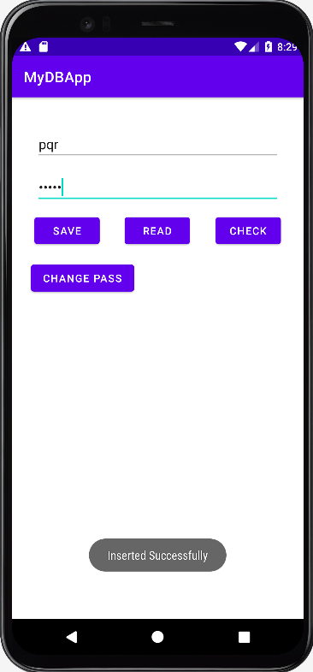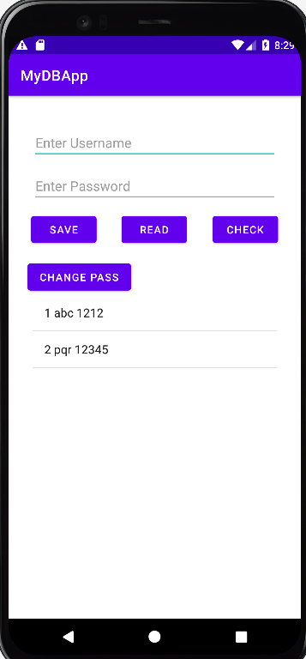

Checking user is present at database :
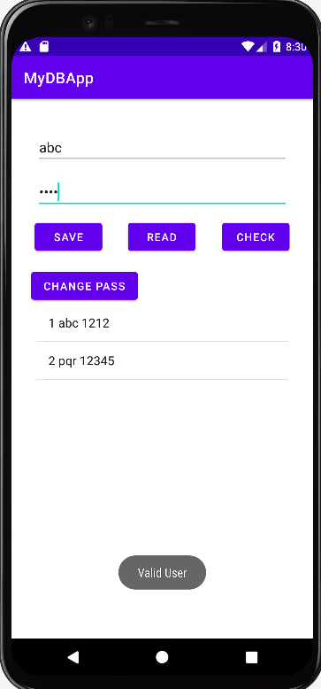
Change password according to the username :
